**Assignment 1:**

Pseudocode Development - Task: Write a detailed pseudocode for a simple program that takes a number as input, calculates the square if it's even or the cube if it's odd, and then outputs the result. Incorporate conditional and looping constructs.

**Solution:**

**Pseudocode:**

1. Start

2. take input from user to enter a number and store it in a variable called 'number'.

3. Check if the number is even or odd using the modulo operator '%':

3.1 If number % 2 equals 0 (even):

3.1.1 Calculate the square of the number and store it in a variable called 'result'.(number*number).

3.2 Else:

3.2.1 Calculate the cube of the number and store it in 'result'(number*number*number).

4. Output the value of 'result'.

5. End

**Algorithm:**

int main () {

int num, result; #Comments

scanf("%d", &num);

if (num % 2 == 0) { // Determine if the number is even or odd

result = num * num; // If even, calculate square

} else {

result = num * num * num; // If odd, calculate cube

}

**Flowchart:**

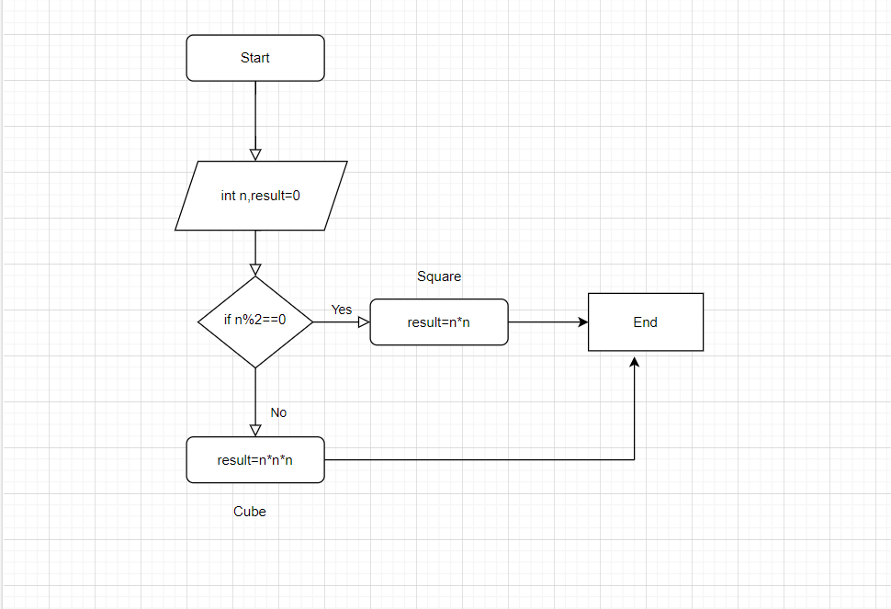

**Code:**

